
RIGA TECHNICAL UNIVERSITY
FACULTY OF COMPUTER SCIENCE AND INFORMATION TECHNOLOGY
INSTITUTE OF APPLIED COMPUTER SYSTEMS

Practical assignment #4
“Database Management Systems”
Design and implementation of database

Author: Doston Hamrakulov
Course, group:
Student card no.: 151ADB089

Checked: Peteris Rudzajs

2015 / 2016 study year
Content

1 Description for Creating FROM and ROPORT 3
2 Main sections of practical work ..... 4

Description – Form and Report:
Create one report with at least 2 levels of grouping and aggregation functions; alternative data should be represented, e.g., date printed, page X of N, etc.
Create form, that allows enter data, format it properly, assign readable names to control elements (e.g., txt prefix for textboxes, cmb for command buttons etc. - for whole list of prefixes see lecture slides). Add some controls to navigate between records. Show other features of form creation and design you have learned!
Unnecessary data should be hidden from the user. (p.s. I can suggest you form tasks after you submit DB design).

Submit a report with short description how this form and report could be used, and necessary screenshots.
All screenshots should be provided, explaining step by step how you create, modify, view the the report and form.

If it is not written in report (Word, PDF), it's not done!

Topic description

I have created Query Design of tblProduct:
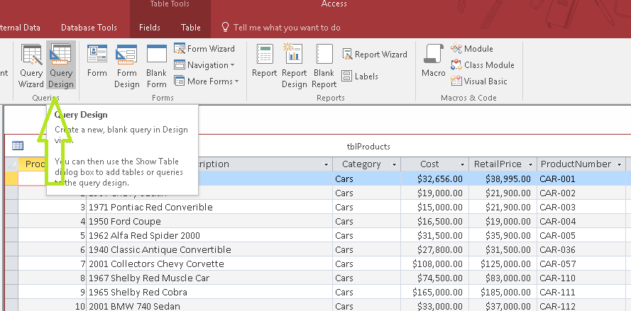

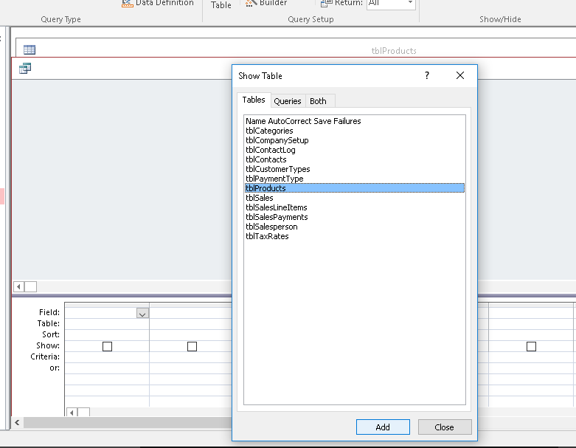
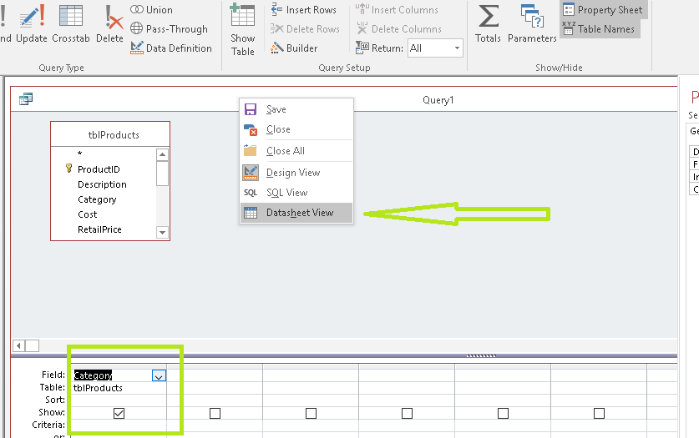

You can see in Query, names of Cars, Minivans and Suv are similar:
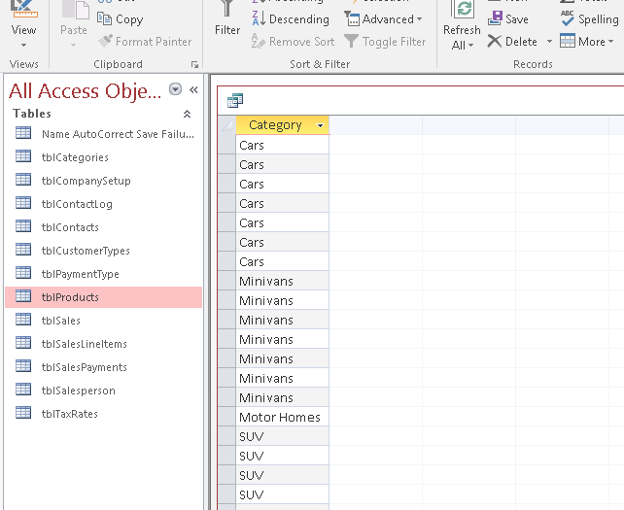
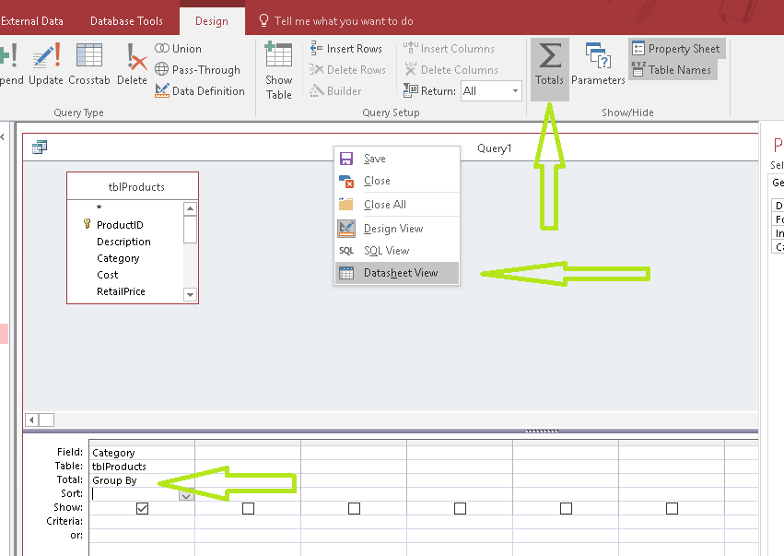

You can see the result of Group By function:

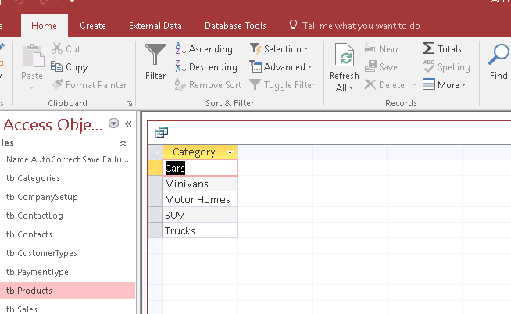
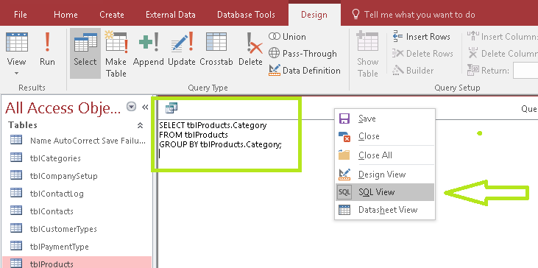

I used Max function :
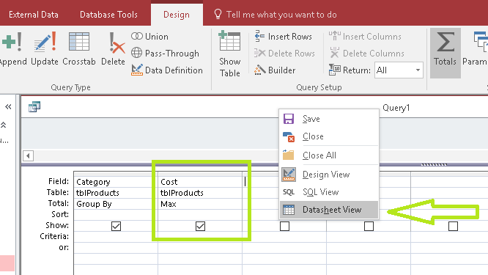
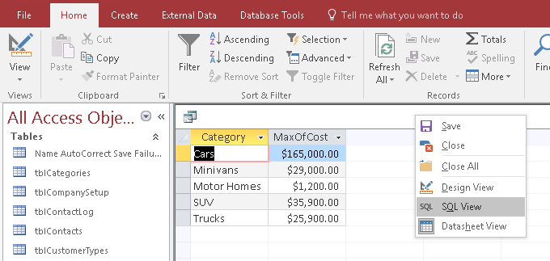
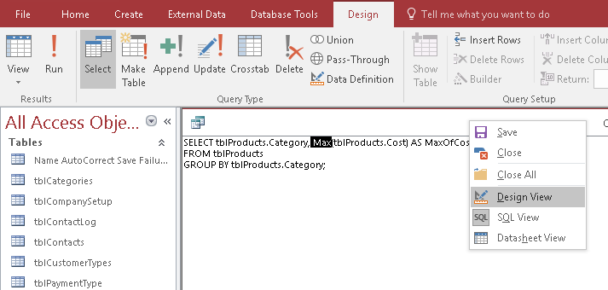

And Group By, Count, Min, Avg and Sum:
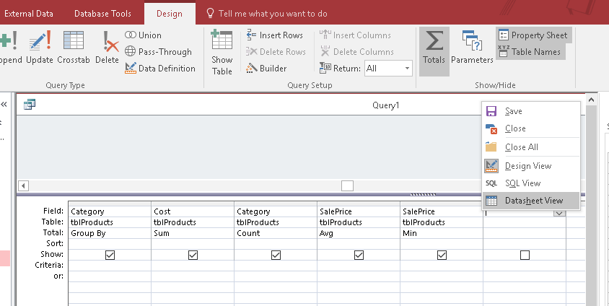
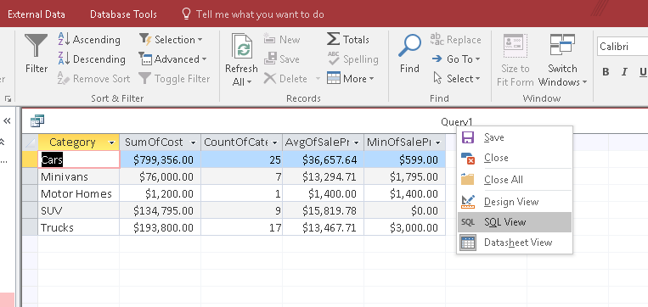
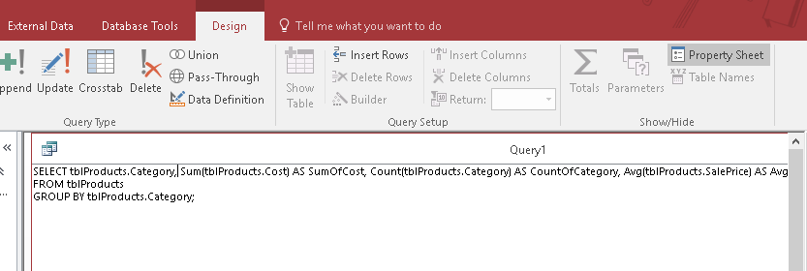

Let`s build Form:

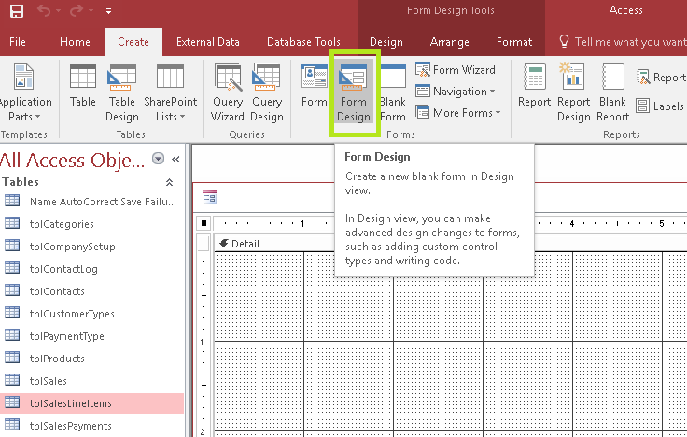
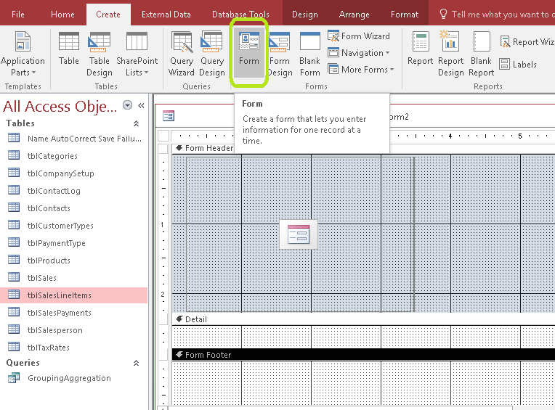
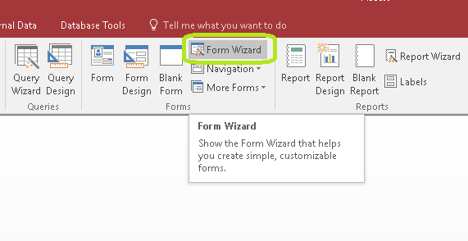
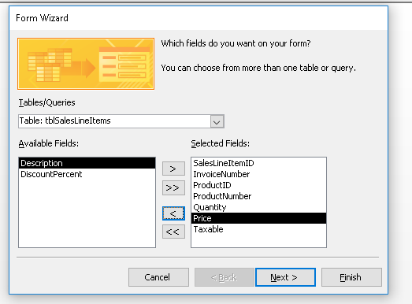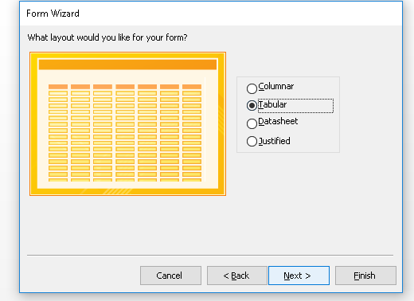
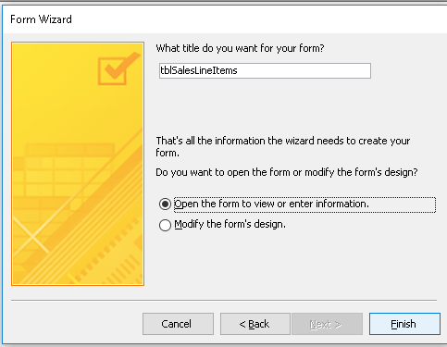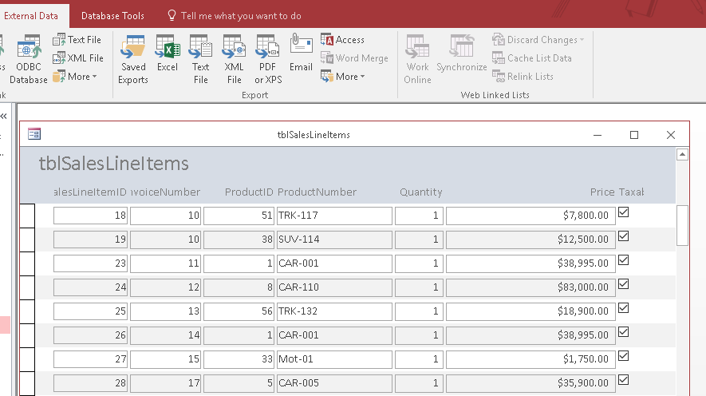

I adjusted the form for printing and printed PDF , I have provided you can check it
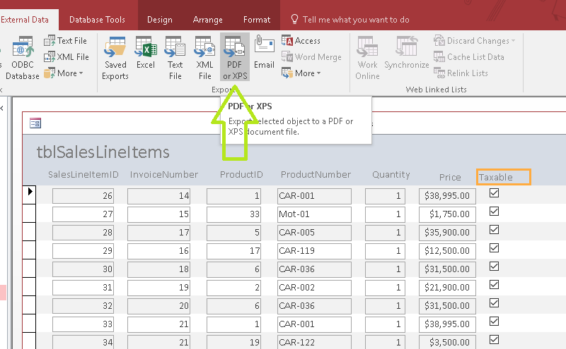
I have created Blank Form and changed Design View:
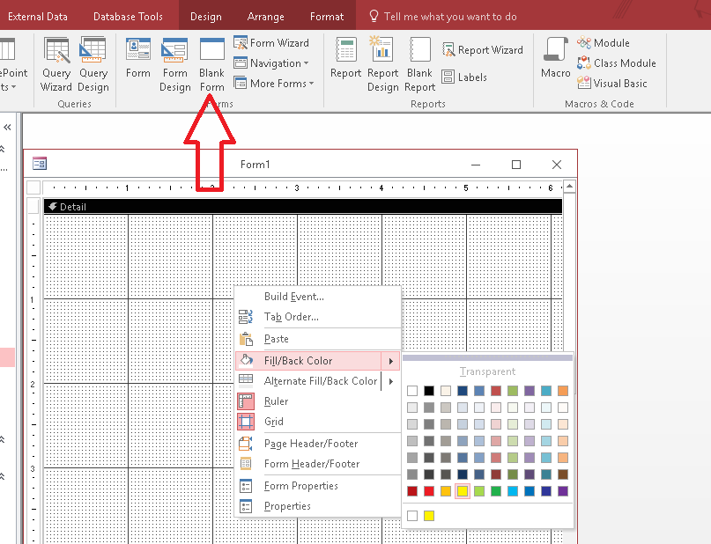

I put button in order to open th Form :
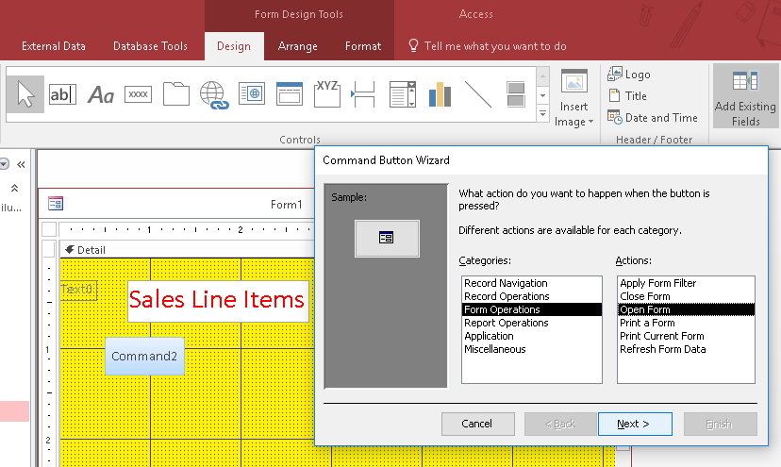
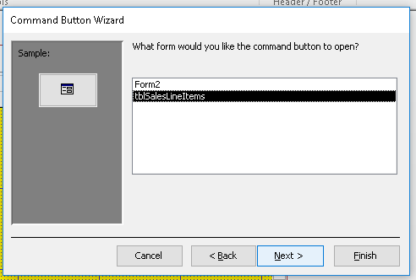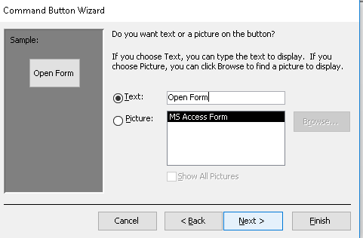
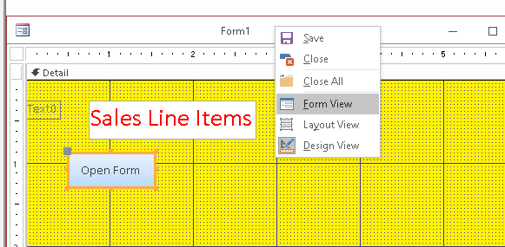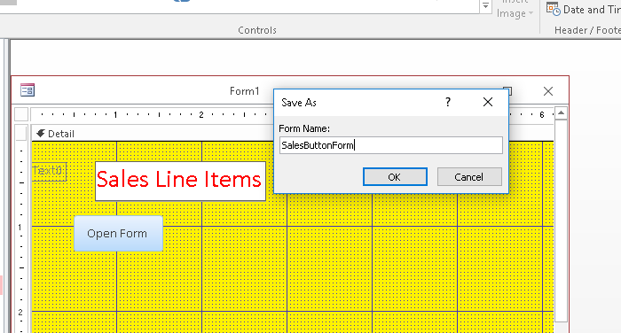
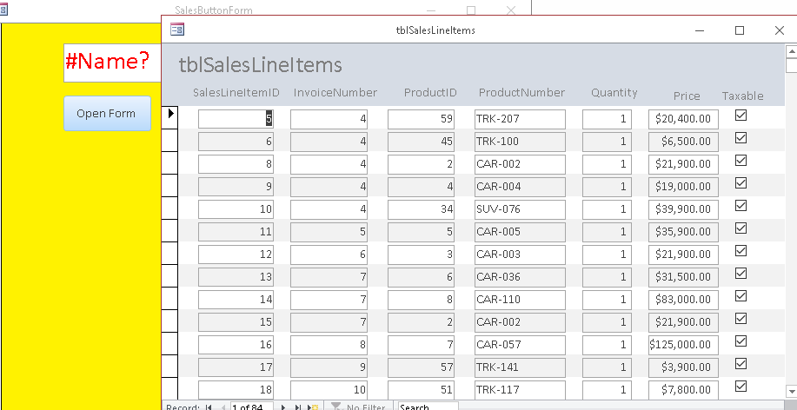

And I also added buttons in SalesLineItems form:
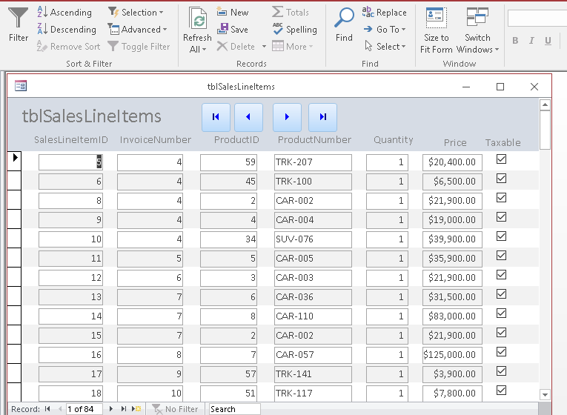
Datasheet Form is created and you can see the result is on the background:
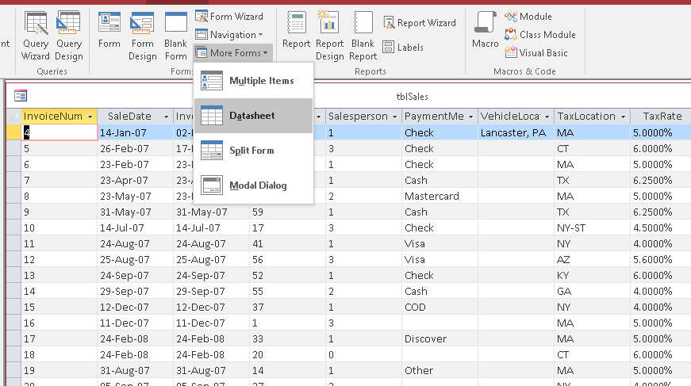

Creation of Query :
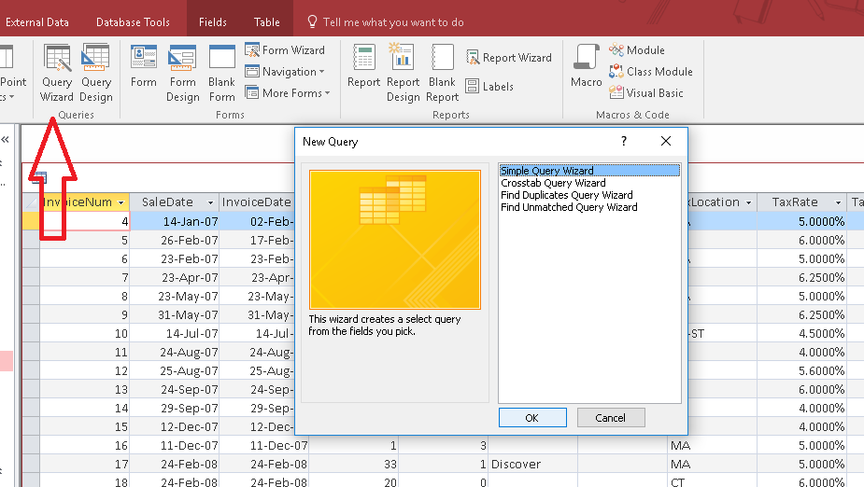
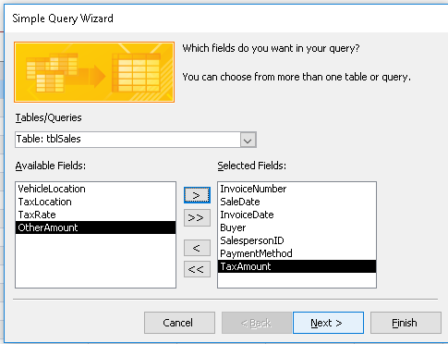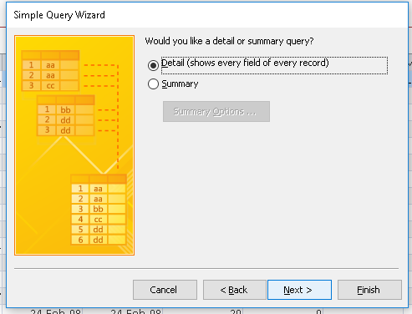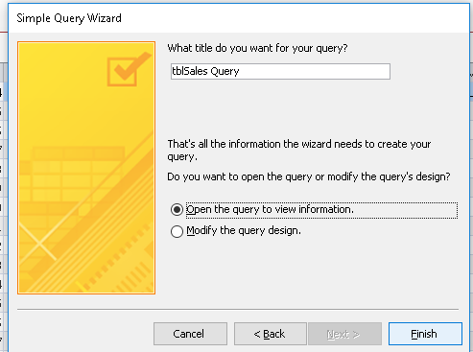
Query:
I have totaly made two Query, first one which you have seen at the beginning of this report and second one is this:

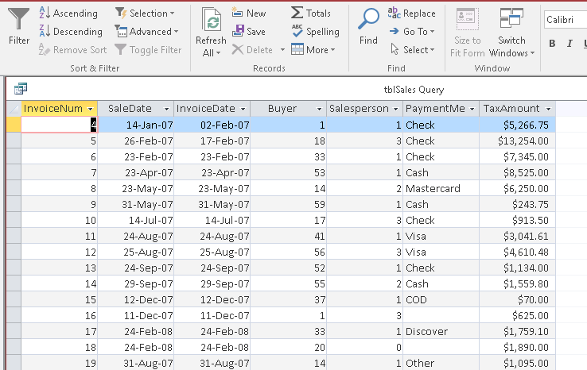

Design View of Query:

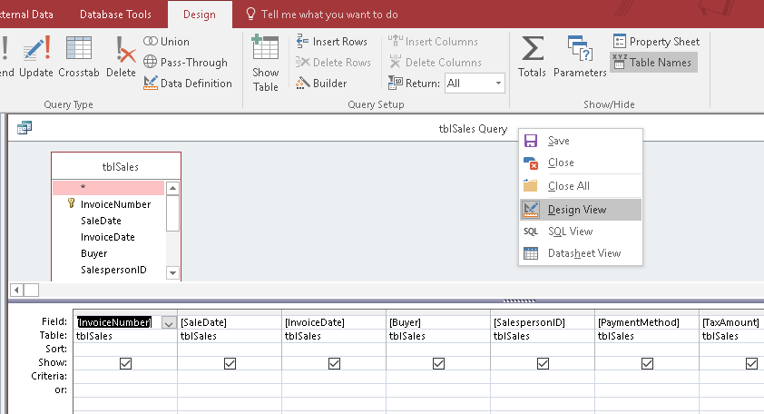

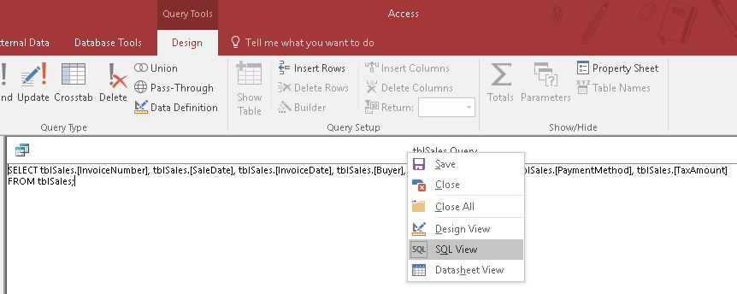

Method of Creation of Report:

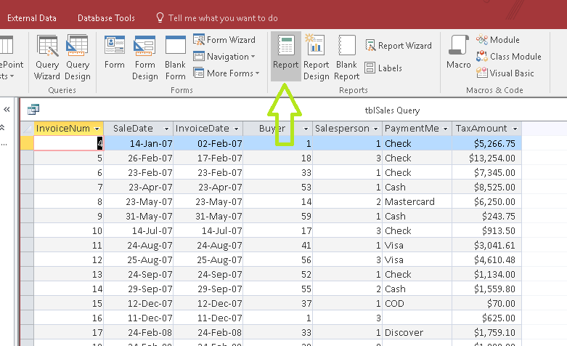

The result:
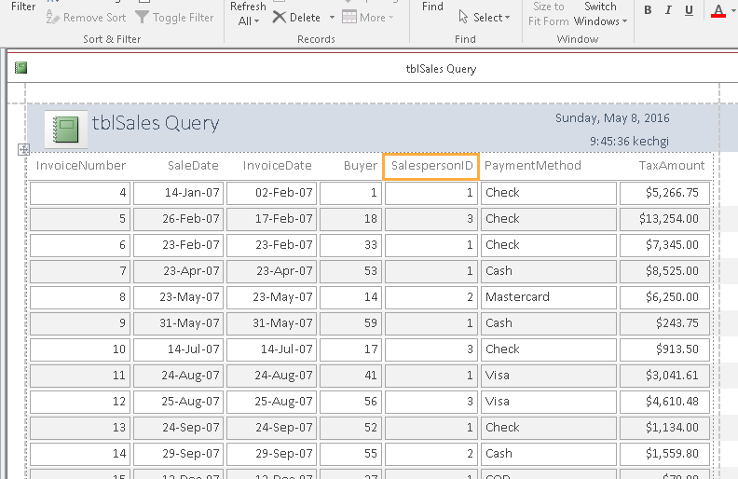

Printing Report:
Formatting Report
Before
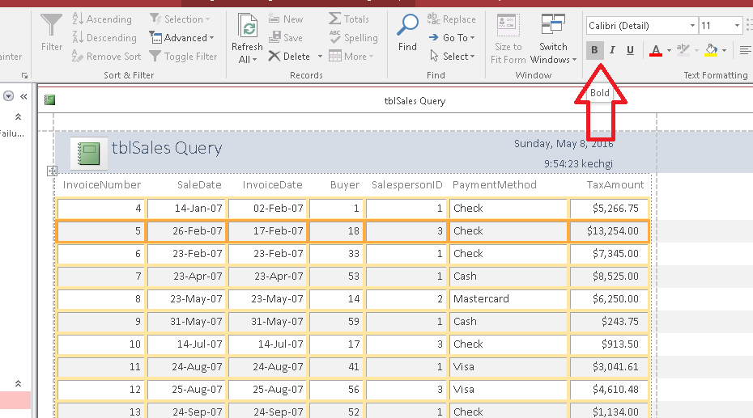
After:
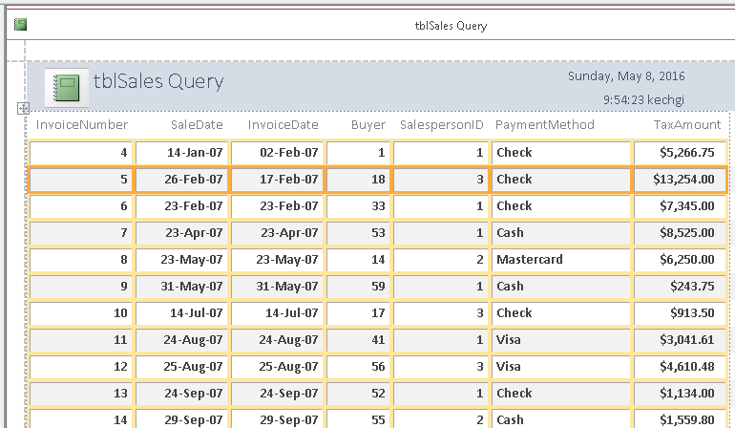

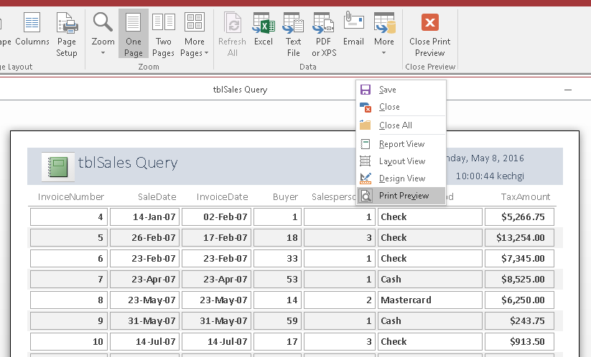

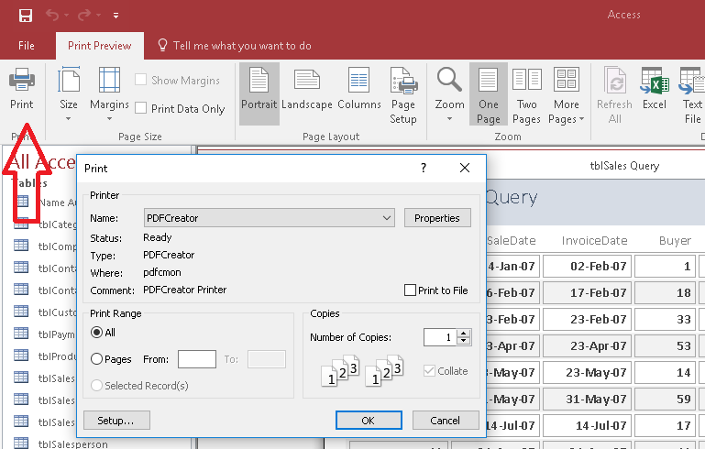

I have supplied the Report in Assignment folder you can chact it

In addition, I utelized Logo and Lebel:
